Author | Lottie Hamer | Target group | All employees, consultants and volunteers
Issued | September 2020
Approved by | Education Committee | Next review | September 2022

Relationships and Sex Education (RSE) Policy

Aims
The aims of relationships and sex education (RSE) at our school are to:
- Provide a framework in which sensitive discussions can take place
- Prepare students for puberty, and give them an understanding of sexual development and the importance of health and hygiene
- Help students develop feelings of self-respect, confidence and empathy
- Create a positive culture around issues of sexuality and relationships
- Teach students the correct vocabulary to describe themselves and their bodies

Statutory requirements
As a primary academy school we must provide relationships education to all students as per section 34 of the Children and Social work act 2017.
We do not have to follow the National Curriculum but we are expected to offer all students a curriculum that is similar to the National Curriculum including requirements to teach science which would include the elements of sex education contained in the science curriculum.
In teaching RSE, we are required by our funding agreements to have regard to guidance issued by the secretary of state as outlined in section 403 of the Education Act 1996.
At this school we teach RSE as set out in this policy.

Policy development
This policy has been developed in consultation with staff, students and parents and approved by the Trust Education Committee. The consultation and policy development process involved the following steps:
- Review – The Trust Head of Legal reviewed all relevant information including relevant national and local guidance to produce a draft template. This was reviewed by the Trust Education Executive Team and then approved by the Trust Education Committee.
- Staff consultation – all school staff were given the opportunity to look at the policy and make recommendations.
- Parent/stakeholder consultation – parents and any interested parties were sent information about the policy and were invited to ask questions and make comments.
- Student consultation – we investigated what exactly students want from their RSE.
- Ratification – once amendments were made in light of the consultations, the policy was shared with senior Trust staff and the Local Governing Body and ratified.

Definition
RSE is about the emotional, social and cultural development of students, and involves learning about caring and respectful relationships, sexual health, sexuality, healthy lifestyles, diversity and personal identity, respect and equality.
RSE involves a combination of sharing information and exploring issues and values.
RSE is not about the promotion of sexual activity.

Curriculum
Our curriculum is set out as per Appendix 1, but we may need to adapt it as and when necessary.
We have developed the curriculum in consultation with parents, students and staff, taking into account the age, needs and feelings of students. If students ask questions outside the scope of this policy, teachers will respond in an appropriate manner, so they are fully informed and don’t seek answers online.
Primary sex education will focus on:
- Preparing boys and girls for the changes that adolescence brings
- How a baby is conceived and born
For more information about our curriculum, see our curriculum map in Appendix 1.

Delivery of RSE
RSE is taught within the personal, social, health and economic (PSHE) education curriculum. Biological aspects of RSE are taught within the science curriculum, and other aspects are included in religious education (RE). Circle times that deal with RSE topics will also be held at the teacher’s discretion as and when they are needed. Children with SEN will receive extra support as per their individual needs in understanding the core concepts within RSE to ensure any misconceptions and worries are addressed. If required, children may be prepped for RSE teaching in the week or weeks prior to these lessons.
Relationships education focuses on teaching the fundamental building blocks and characteristics of positive relationships including:
- Families and people who care for me
- Caring friendships
- Respectful relationships
- Online relationships
- Being safe
For more information about our RSE curriculum and specific coverage, see Appendices 1 and 2.
These areas of learning are taught within the context of family life taking care to ensure that there is no stigmatisation of children based on their home circumstances (families can include single parent families, LGBT parents, families headed by grandparents, adoptive parents, foster parents/carers amongst other structures) along with reflecting sensitively that some children may have a different structure of support around them (for example: looked after children or young carers).

Roles and responsibilities

The Trust Education Committee
The Trust Education Committee will approve the RSE policy and hold the Headteacher to account for its implementation.

The Headteacher
The Headteacher is responsible for ensuring that RSE is taught consistently across the school, and for managing requests to withdraw students from non-statutory/non-science components of RSE (see Parents’ right to withdraw).

Staff
Staff are responsible for:
- Delivering RSE in a sensitive way
- Modelling positive attitudes to RSE
- Monitoring progress
- Responding to the needs of individual students
- Responding appropriately to students whose parents wish them to be withdrawn from the non-statutory/non-science components of RSE
Staff do not have the right to opt out of teaching RSE. Staff who have concerns about teaching RSE are encouraged to discuss this with the headteacher.
Class teachers all teach RSE to their classes. Additional teaching or gender specific teaching may be undertaken by SLT as needed.
Students are expected to engage fully in RSE and, when discussing issues related to RSE, treat others with respect and sensitivity.

Parents’ right to withdraw
Parents do not have the right to withdraw their children from relationships education.
Parents do have the right to withdraw their children from the non-statutory/non-science components of sex education within RSE. These are highlighted in yellow below. Requests for withdrawal should be put in writing and addressed to the Headteacher. The request will be discussed with parents and appropriate action will be taken. As a school we acknowledge and celebrate cultural and religious diversity and are sensitive to any issues such diversity may bring in relation to RSE. Alternative work will be given to pupils who are withdrawn from RSE.

Training
Staff are trained on the delivery of RSE as part of their induction and it is included in our continuing professional development calendar.
The Headteacher will also invite visitors from outside the school, such as school nurses or sexual health professionals, to provide support and training to staff teaching RSE.

Monitoring arrangements
The delivery of RSE in our school is monitored by PSHE Lead and SLT through:
Planning scrutinies, learning walks and PSHE floor books.
Students’ development in RSE is monitored by class teachers as part of our internal assessment systems.
This policy will be reviewed by the Trust every two years. At every review, the policy will be approved by the Trust Education Committee.

Appendix 1: Relationships and sex education curriculum map
Year group | Term | Topic/theme details | Resources
Year 1 | Autumn | For lesson breakdowns see Appendix 3 RSE schemes of work  Respectful relationships  - Identify different behaviours which may be bullying.  Respectful relationships  - Wants and needs  - Girl and boy needs and wants  - Celebrating being me  Online relationships  - Personal information  Being Safe  - Places and people who make me feel safe  - A safe and inviting classroom  - Keeping safe at home
 | Spring
 | Summer | Caring relationships  - Qualities of a good friend  - The importance of compliments  - How to talk to friends  Growing and Caring for Ourselves  - Keeping clean  - Growing and changing and male and female differences  - Naming body parts including external genitalia  - Different types of families
Year 2 | Autumn | Caring Friendships  - Identifying bullying  Understanding and resolving conflict
 | Spring | Respectful relationships  - Needs and wants  - Life around the world  - Gender stereotypes in careers  Online relationships  - Personal information  Who to trust online
 | Summer | Respectful relationships  - What makes a good friend?  - Understanding the PANTS rule  - Girl and boy difference and gender stereotypes  - Differences between male and female animals  Growth and development  - Understanding how the difference between males and females is part of lifecycles  - Sexual difference and naming body parts including genitalia*  Statutory science curriculum content*: children learn that animals, including humans, have offspring that grow into adults. They are introduced to the concepts of reproduction and growth, but not how reproduction occurs.
Year 3 | Autumn | Respectful and caring relationships  - Defining bullying and unkindness  - Resolving conflict  What to do when a conflict escalates
 | Spring | Online relationships  - Staying safe online
 | Summer | Respectful and caring relationships  - Being a good friend  - Stereotyping males and females and how this is linked to discrimination  Growth and development (PSHE/ Science)  - Male and female differences and naming body parts including genitalia  - Different kinds of touch  - Personal space and how to deal with unwanted touch.  - Different types of family including same sex partnerships  Who to go to for help
Year 4 | Autumn | Respectful relationships  The role of victims, bullies and bystanders
 | Spring | Online relationships  - Understand that not everything online is trustworthy  - Making decisions about what to trust online  Respectful relationships  - Understanding how stereotypes can label people  - Qualities of a good friend
 | Summer | Growth and Development  - Stages of the human lifecycle  - Bodily and emotional changes during puberty  - How changes during puberty are linked to human reproduction
Year 5 | Autumn | Respectful relationships  - Fairness and unfairness. How and why people are excluded  - Understanding reasons for migration  Discussing gender stereotypes
 | Spring | Online safety  - Appropriate content and sharing online.  Who to go to for help
 | Summer | Growth and Development  - The changing adolescent body: changes since birth  - Menstruation and wet dreams*  - Hygiene during puberty  Emotional changes and managing them during puberty  *Statutory science curriculum content: children are taught about the life cycles of humans and animals, including reproduction. They also learn about the changes that happen in humans from birth to old age. This includes learning what happens in puberty, including periods.
Year 6 | Autumn | Respectful relationships  - Exploring ways we are similar and different  - What trust means online  The concept of appearance ideals
 | Spring | Respectful relationships  - Stereotypes  - Homelessness  - Challenging stereotypes  Online relationships  Identifying risky behaviour and manipulation
 | Summer | Puberty, relationships and reproduction  - How and why the body changes during puberty in preparation for reproduction  - Physical and emotional behaviour in relationships  - Process of conception and pregnancy*  Positive and negative ways of communicating in a relationship
*Please keep in mind that as part of statutory science curriculum In Year 2, children learn that animals, including humans, have offspring that grow into adults. They should be introduced to the concepts of reproduction and growth, but not how reproduction occurs.
In Year 5, children are taught about the life cycles of humans and animals, including reproduction. They also learn about the changes that happen in humans from birth to old age. This includes learning what happens in puberty, including periods.

Appendix 2: By the end of primary school students should know
Topic | Students should know
Families and people who care about me | - That families are important for children growing up because they can give love, security and stability  - The characteristics of healthy family life, commitment to each other, including in times of difficulty, protection and care for children and other family members, the importance of spending time together and sharing each other’s lives  - That others’ families, either in school or in the wider world, sometimes look different from their family, but that they should respect those differences and know that other children’s families are also characterised by love and care  - That stable, caring relationships, which may be of different types, are at the heart of happy families, and are important for children’s security as they grow up  - That marriage represents a formal and legally recognised commitment of two people to each other which is intended to be lifelong  - How to recognise if family relationships are making them feel unhappy or unsafe, and how to seek help or advice from others if needed
Caring friendships | - How important friendships are in making us feel happy and secure, and how people choose and make friends  - The characteristics of friendships, including mutual respect, truthfulness, trustworthiness, loyalty, kindness, generosity, trust, sharing interests and experiences and support with problems and difficulties  - That healthy friendships are positive and welcoming towards others, and do not make others feel lonely or excluded  - That most friendships have ups and downs, and that these can often be worked through so that the friendship is repaired or even strengthened, and that resorting to violence is never right  - How to recognise who to trust and who not to trust, how to judge when a friendship is making them feel unhappy or uncomfortable, managing conflict, how to manage these situations and how to seek help or advice from others, if needed
Respectful relationships | - The importance of respecting others, even when they are very different from them (for example, physically, in character, personality or backgrounds), or make different choices or have different preferences or beliefs  - Practical steps they can take in a range of different contexts to improve or support respectful relationships  - The conventions of courtesy and manners  - The importance of self-respect and how this links to their own happiness  - That in school and in wider society they can expect to be treated with respect by others, and that in turn they should show due respect to others, including those in positions of authority  - About different types of bullying (including cyberbullying), the impact of bullying, responsibilities of bystanders (primarily reporting bullying to an adult) and how to get help  - What a stereotype is, and how stereotypes can be unfair, negative or destructive  - The importance of permission-seeking and giving in relationships with friends, peers and adults
Online relationships | - That people sometimes behave differently online, including by pretending to be someone they are not  - That the same principles apply to online relationships as to face-to face relationships, including the importance of respect for others online including when we are anonymous  - The rules and principles for keeping safe online, how to recognise risks, harmful content and contact, and how to report them  - How to critically consider their online friendships and sources of information including awareness of the risks associated with people they have never met  - How information and data is shared and used online
Being safe | - What sorts of boundaries are appropriate in friendships with peers and others (including in a digital context)  - About the concept of privacy and the implications of it for both children and adults; including that it is not always right to keep secrets if they relate to being safe  - That each person’s body belongs to them, and the differences between appropriate and inappropriate or unsafe physical, and other, contact  - How to respond safely and appropriately to adults they may encounter (in all contexts, including online) whom they do not know  - How to recognise and report feelings of being unsafe or feeling bad about any adult  - How to ask for advice or help for themselves or others, and to keep trying until they are heard  - How to report concerns or abuse, and the vocabulary and confidence needed to do so  - Where to get advice e.g. family, school and/or other sources

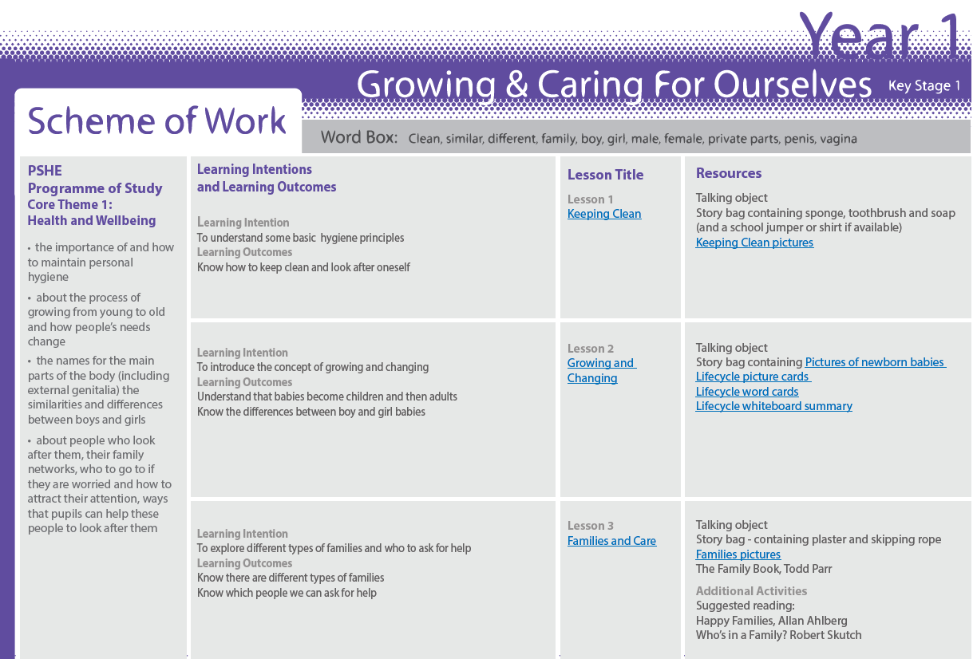
Appendix 3: RSE schemes of work
Year 1

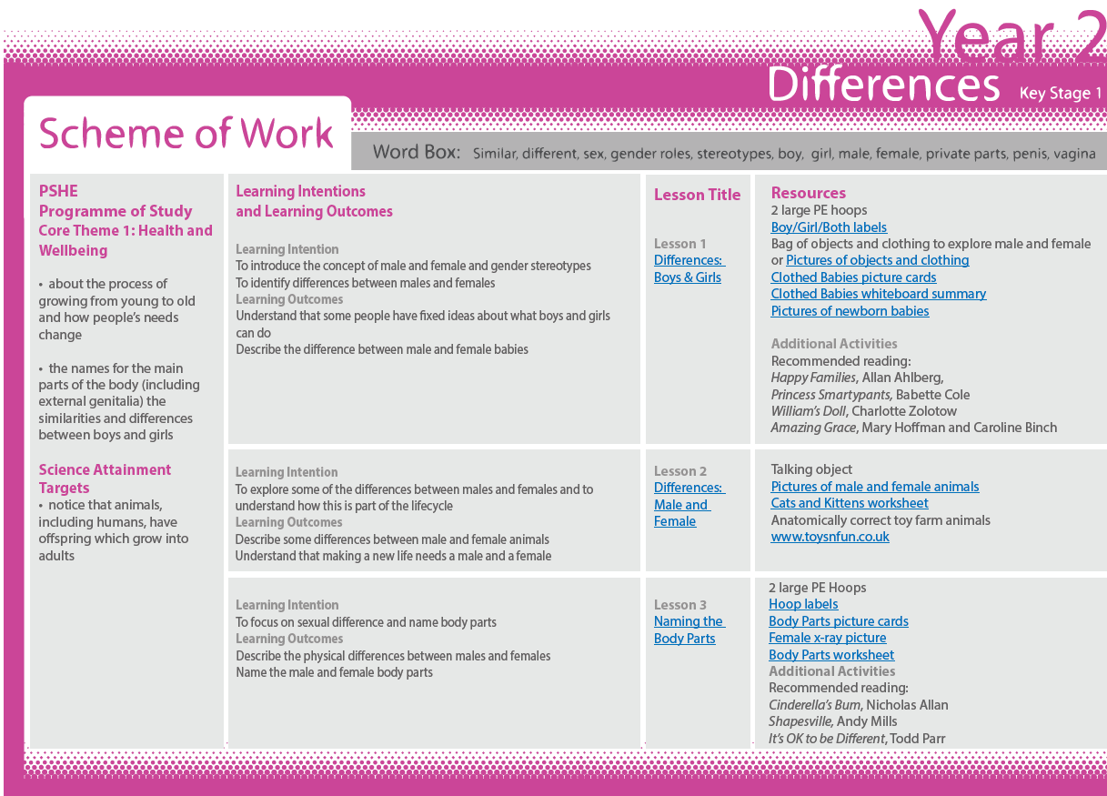
Year 2

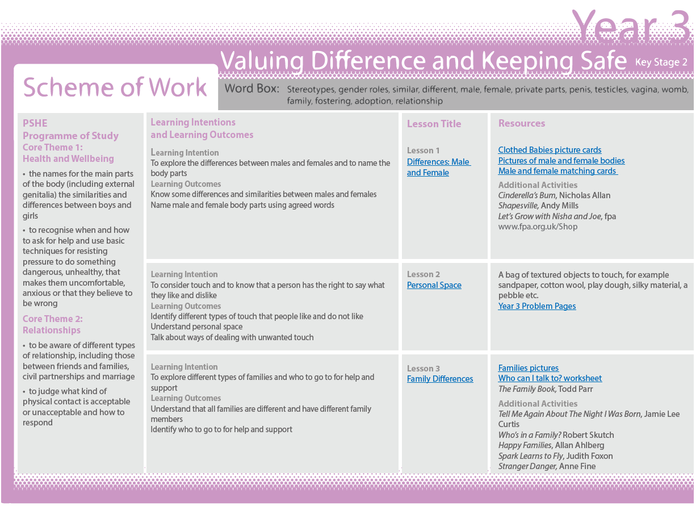
Year 3

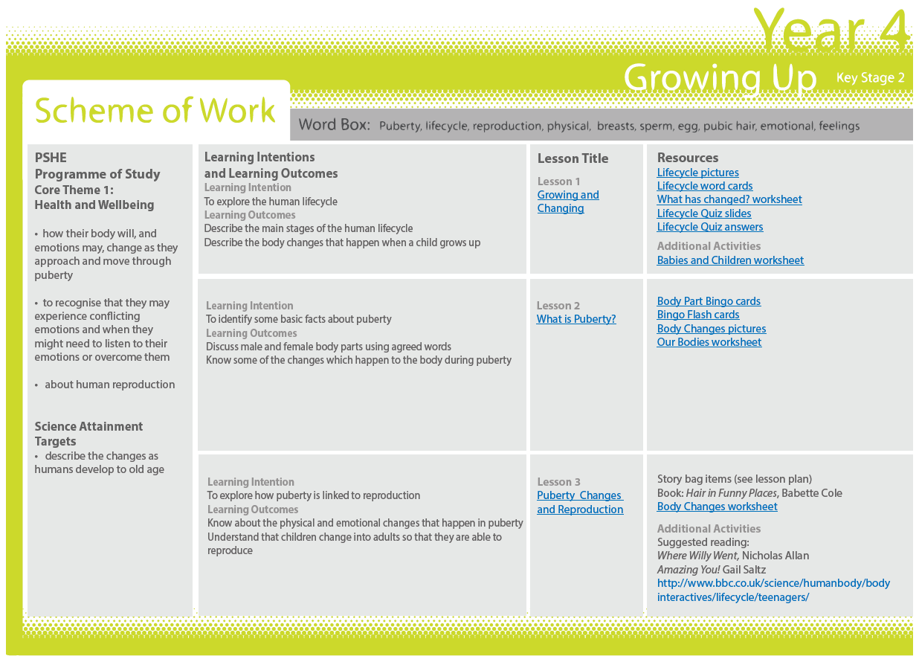

Year 4

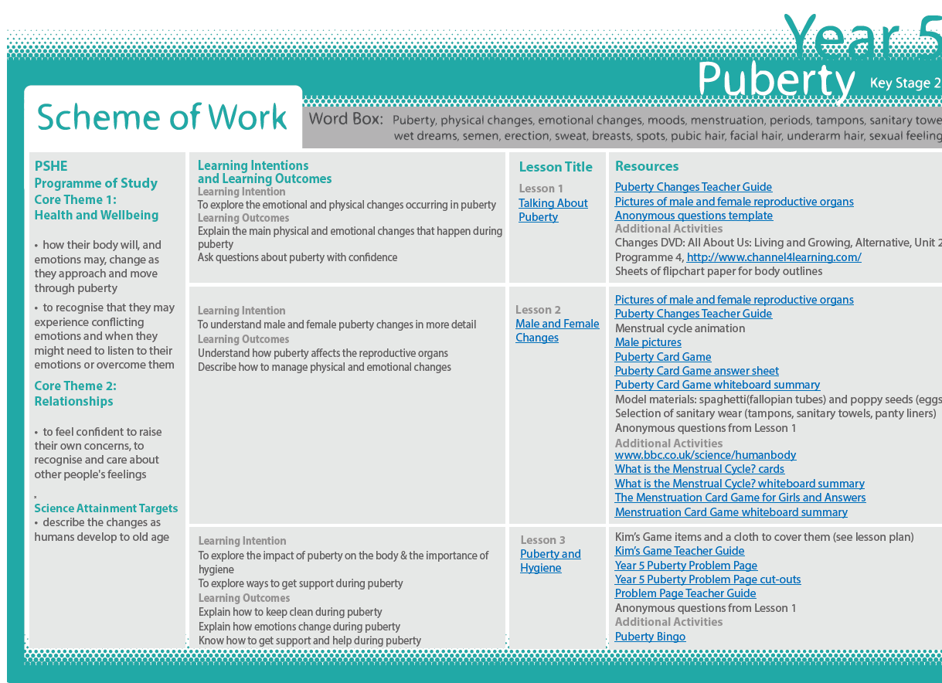
Year 5

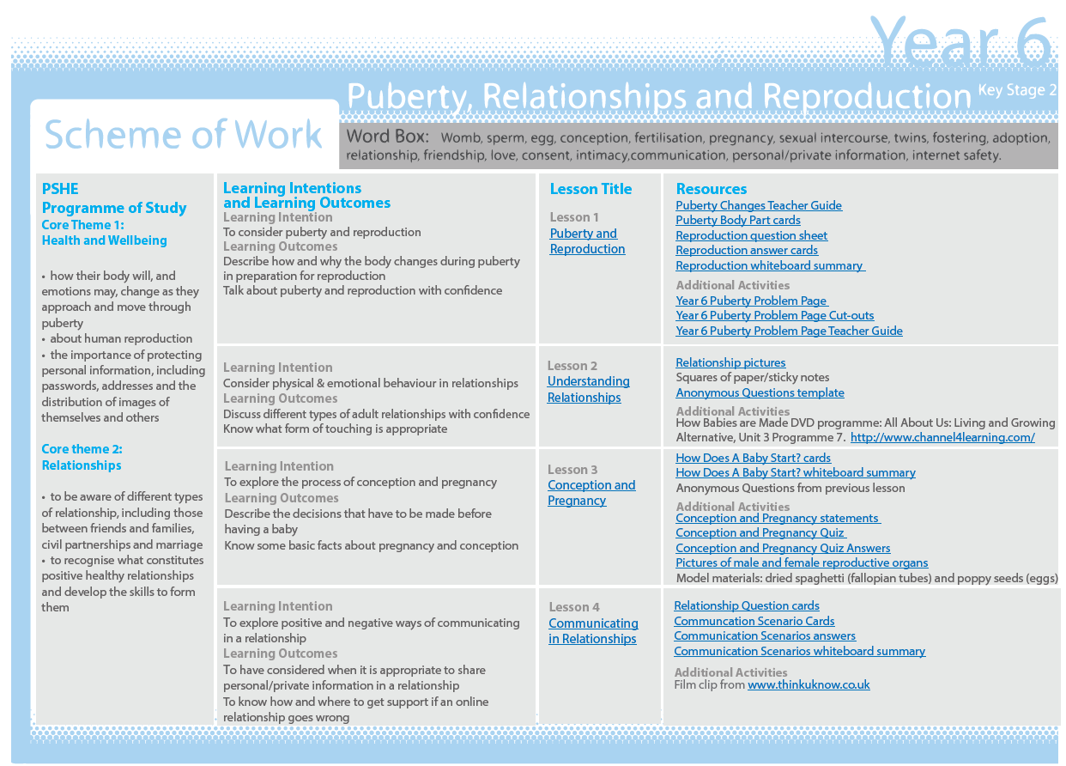
Year 6

