Author | Anna Miller | Target group | All employees, consultants and volunteers
Issued | September 2025 | Target group | All employees, consultants and volunteers
Approved by | Education Executive Team | Next review | September 2027

Relationships, Sex, and Health Education (RSHE) Policy

Rationale and Ethos
At Abacus Belsize Primary School, we define Relationships, Health and Sex Education (RSHE) as a curriculum that enables children to understand and develop positive, respectful and safe relationships; make informed choices about their physical and emotional health; and explore how to lead happy, confident lives, both now and in the future. Where sex education is included, it is delivered in an age-appropriate, factual, and sensitive manner, preparing students for the changes that adolescence brings.

We believe that RSHE is an essential part of our children’s education because it empowers them to understand their bodies, manage their emotions, develop empathy, and build strong relationships. It also plays a vital role in safeguarding by teaching children about boundaries, consent and how to seek help if needed.

The overarching principles of our RSHE provision are to:
- Promote self-respect, confidence and resilience
- Celebrate diversity and challenge stereotypes
- Equip students with the skills to make informed safe choices
- Support physical and mental wellbeing
- Embed our THRIVE school values

The intended outcomes of our curriculum are that students will:
- Know and understand the importance of family, friendship, personal hygiene, healthy lifestyles, puberty and online safety
- Understand they have a right to feel safe, be respected, be heard, and access information and support
- Understand they have a responsibility to treat others with kindness and respect, look after their wellbeing and contribute positively to their community
- Develop the skills of communication, emotional literacy, decision-making and conflict resolution
- Develop the attributes of empathy, confidence, integrity and respect for themselves and others
- We view the partnership of home and school as vital in providing a consistent and supportive framework for RSHE. We engage with parents and carers by sharing curriculum content in advance, offering opportunities for discussion, and welcoming feedback as part of our commitment to transparency and trust.
- In all that we do, our RSHE curriculum reflects our belief that children deserve to grow up understanding themselves and others, prepared for the challenges of modern life, and supported to flourish as confident, compassionate members of society.
- Understand protected characteristics in an age-appropriate way

At Abacus Belsize Primary School, we believe that high-quality Relationships, Sex and Health Education (RSHE) is essential in preparing our students to thrive in an ever-changing world. Our RSHE curriculum is designed to equip students with the knowledge, skills and values they need to develop healthy, respectful relationships, make informed choices and understand their physical and emotional development as they grow.
In line with statutory guidance from the Department for Education (DfE), our programme supports students to become confident, resilient individuals, who are aware of their rights and responsibilities. It is rooted in our whole-school commitment to safeguarding, inclusion and personal development. We believe that by teaching RSHE in a safe and age-appropriate way, we can help prevent misconceptions, support mental wellbeing and empower our students to navigate life’s challenges with empathy and integrity.
Our approach to RSHE is inclusive, reflecting the diverse community we serve and promoting equality of opportunity for all students. We recognise the vital role parents and carers play in this area and work in partnership with them to ensure the best outcomes for every child.

Aims
The aims of relationships, sex, and health education (RSHE) at our school are to:
- Promote the spiritual, moral, cultural, mental, and physical development of students at the school and of society.
- Prepare students for the opportunities, responsibilities, and experiences of later life.
- Provide knowledge and information which is inclusive and meets the needs of all our students (and their families) including those with protected characteristics.
- Create a positive culture around issues of self-esteem and confidence, relationships and sexuality ensuring gender and LGBT+ equality.
- Help students develop and understand their feelings, behaviours, and emotions and those of others so they can lead fulfilling and enjoyable lives.
- Provide students with the right tools to enable them to seek information and support (both within and outside school) should they need it.
- Help students to develop skills (language, decision making, choice, assertiveness), promoting ambition and aspiration to make the most of their abilities whilst coping with the influences of their peers and the media.
- Recognise and respect themselves and others, the views of others, backgrounds, cultures, values, and experiences.
- Develop skills for a healthier, safer lifestyle to allow them to respect and care for their bodies and be prepared for changes through puberty and adulthood.
- Teach students the correct vocabulary to describe themselves and their bodies, supporting students to keep themselves safe.
- Teach sex education as part of a wider social, personal, and moral education.
- Ensure all students understand reproduction.
- Provide a framework in which sensitive discussions can take place.

Policy development
This policy has been developed in consultation with staff, Trustees, students, and parents/carers and has been approved by the Executive Education Team.
The policy will be reviewed every two years or sooner if there is a need to respond to any amendments made to the DfE statutory guidance for Relationships, Sex, and Health Education.
Staff, Trustees, students, and parents/carers will be consulted every time the policy is reviewed and will be invited to share feedback by completing a survey and attending a feedback session hosted by leaders at the school. All feedback will be considered and will help to inform future revisions to the policy and curriculum.

Statutory Requirements
As a primary academy school, we must provide relationship education to all students as per section 34 of the Children and Social work act 2017. and relationships and health education in line with the Relationships Education, Relationships and Sex Education (RSE) and Health Education DfE Statutory Guidance (Updated September 2021). Please click on the link to access a copy of the statutory guidance. Sex education in not statutory in primary schools.
In teaching RSHE, we are required by our funding agreements to have regard to guidance issued by the secretary of state as outlined in sections 403, 407, and 407 of the Education Act 1996. We also have regard to legal duties set out in
- Part 6, chapter 1 of the Equality Act 2010
- The Public Sector Equality Duty (as set out in section 149 of the Equality Act 2010). This duty requires public bodies to have due regard to the need to eliminate discrimination, advance equality of opportunity and foster good relations between different people when carrying out their activities.
Sex Education (non-statutory)
Statutory
Currently, the National Curriculum states that the following statutory subject areas be taught through science and relationships/health education:
The main external body parts (including external genitalia). Please note that we introduce the scientific terminology for body parts from Key Stage 1.
The human body as it grows from birth to old age (including foetal development and puberty).
Reproduction in some plants and animals.
Non-Statutory
Following consultation with staff, Trustees, parents/carers, and students, we have chosen to include the following non-statutory element of sex education within our curriculum.
Our sex education curriculum complements the statutory components of the science curriculum (reproduction in humans – to include learning about the structure and function of the male and female reproductive systems, sexual intercourse, fertilisation, gestation, and birth) and ensures students have the awareness and knowledge they need to keep themselves safe. Our primary sex education curriculum includes a focus on:
• Preparing boys and girls for the changes that adolescence brings
• How a baby is conceived and born
Parents/carers have a right to withdraw their children from sex education within the relationships, sex, and health education curriculum; for more information see the ‘Right to Withdraw’ section within this policy. Parents/carers do not have the right to withdraw their children from the statutory elements of the science curriculum related to sex education or from health education which includes a focus on puberty.

Legislation and supporting guidance.
We used the following legislation and guidance to inform the development of this policy. Click on the hyperlink below to view the document.
- Education Act 1996
- Learning and Skills Act (2000)
- Children and Social Work Act 2017
- Keeping Children Safe in Education
- Equality Act 2010
- SEND Code of Practice 0 - 25 years (statutory guidance)
- Mental Health and Behaviour in Schools (advice for Schools)
- Preventing and Tackling Bullying (advice for schools, including advice on cyberbullying)
- Promoting Fundamental British Values as part of SMSC in schools
Cross-reference can be made to other Anthem policies to avoid any unnecessary repetition.
These include but are not exclusive of:
- PSHE and Citizenship
- Safeguarding
- Behaviour and Discipline
- Anti-bullying
- Drug and Alcohol

Roles and Responsibilities

The Education Executive Team – will approve the RSHE policy and hold the Headteacher to account for its implementation.

The Trustees – Ultimately have responsibility for the policy.

The Headteacher - is responsible for ensuring that RSHE is taught consistently across the school, and for managing requests to withdraw students from (non-statutory/non-science) components of RSHE. (See right to withdraw).

Staff are responsible for:
- Delivering RSHE in a sensitive way
- Modelling positive attitudes to RSHE
- Monitoring progress
- Evaluating the effectiveness of the curriculum
- Reporting progress to parents/carers
- Responding to the needs of individual students
- Responding appropriately to students whose parents/carers wish them to be withdrawn from the non-statutory components of RSHE by notifying them when sex education is going to be taught and providing alternative lessons for the student where necessary.

Staff do not have the right to opt out of teaching RSHE. Staff who have concerns about teaching RSHE are encouraged to discuss this with the headteacher or deputy head teacher.
Students are expected to engage fully in RSHE and, when discussing issues related to RSHE, treat others with respect and sensitivity.
Staff are trained on the delivery of RSE as part of their induction and it is included in our continuing professional development calendar. The Headteacher will also invite visitors from outside the school, such as school nurses or sexual health professionals, to provide support and training to staff teaching RSE.

Curriculum
RSHE is taught within the personal, social, health and economic (PSHE) education curriculum. RSHE is explicitly taught as a timetabled subject in our school. Key learning in RSHE is also addressed through cross-curricular links in other subjects e.g., I.T. literacy, P.E. and R.E. Teachers will deliver the RSHE curriculum in a way that allows students to explore varying viewpoints by ensuring that information is unbiased and impartial. Classes are taught as mixed genders.
Our RSHE curriculum is set out as per Appendix 1.
This will be reviewed every two years; amendments may be made following feedback from staff, Trustees, parents/carers, and students or due to changes in statutory guidance.
Our curriculum covers all objectives within the DfE statutory guidance for relationships and health education. The DfE statutory guidance document can be viewed here: Relationships Education, Relationships and Sex Education (RSE) and Health Education DfE Statutory Guidance (Updated September 2021).
RSHE focuses on giving students the information they need to help them develop healthy, nurturing relationships of all kinds including:
- Families and people who care for me.
- Caring friendships.
- Respectful relationships.
- Online relationships.
- Being safe.

For more information about our RSHE curriculum, see Appendix 1.

We have carefully planned our curriculum to meet the needs of students in our school. We will regularly review and make adaptations to the curriculum to ensure we continue to meet the diverse and ever-changing needs of our students, or in response to local or global events. You will notice that our RSHE curriculum is a spiral curriculum (key concepts are revisited throughout the curriculum with deepening layers of complexity as students move through the school). We have purposefully designed our RSHE curriculum in this way so that our students can embed their learning of the most important aspects of the curriculum and have dedicated time to practice key skills linked to these very important key concepts. We involve students in their learning by using active learning methods and these include role play, scenarios, discussions, debates, and problem-solving.

Inclusivity and Equality
All schools have a duty under the Equality Act (2010) to ensure that no child is disadvantaged because of their protected characteristic which includes: age, gender, race, disability, religion and belief, sexual orientation, gender reassignment, marriage, and civil partnership.
The DfE guidance states that “at the point at which schools consider it appropriate to teach their pupils about LGBT, they should ensure that this content is fully integrated into their programmes of study for this area of the curriculum rather than delivered as a standalone unit or lesson.’
Every student can see themselves reflected in the curriculum content, the resources, and the school environment. We work hard to ensure that all families in our school community feel valued and diversity is celebrated. This is demonstrated through our curriculum, the books we read, the events we celebrate and the discussions we have within classrooms, assemblies and across the school.
The RSHE curriculum and resources may be adapted and differentiated to meet the specific needs of students with special educational needs (SEND) and learning may be scaffolded to ensure all lessons are inclusive. Teachers will seek specialist advice from the SENCO when required.

Where appropriate, students may receive additional support from a T.A. to ensure that learning of key concepts is secure. This could include pre-teaching of key concepts or vocabulary or follow-up individual/group work after the weekly lesson has taken place.

Teachers, with support from the SENCO. will consider whether it is appropriate for targets linked to the RSHE curriculum to be included within students’ Education Health Care Plans (EHCPs).

Creating a Safe Learning Environment
Teachers create a safe learning environment by informing children in advance of the context of the lesson so that they are prepared. They establish ground rules with students before the lesson and refer to them frequently throughout the lessons. The children will be introduced to the overview of the topics at the start of each half-term so they aware of what is coming and can ask any necessary questions. Where needed, staff will use visuals and pre-teaching to support all students in understanding the ground rules and the content.
Teachers will use distancing techniques; these may include drama. roleplay, scenarios, and use of video clips. Distancing techniques put a space between a difficult subject and an individual student so that the question does not become, ‘what do you think?’ but ‘what might they think?’ instead. It enables tricky questions to be answered and supports students to debate and disagree without anyone feeling personally compromised.
All staff teaching RSHE know that they can access support from the RSHE Lead, SENCO, and Safeguarding Lead if they are faced with difficult questions from students, upcoming topics that may be triggering for some students, questions about how to ensure lessons are fully inclusive or following a safeguarding disclosure. All classes will have a worry box or opportunity for children to record questions that they may wish to know more about. Teachers, with the support of SLT will decide if the questions are appropriate for discussion in the next sessions or if parents/carers should be invited to discuss it individually with their children.

Safeguarding
Teachers are aware that effective RSHE, which brings an understanding of what is and what is not appropriate in a relationship, can lead to a disclosure of a child protection issue. All staff are aware of the school safeguarding procedures; and this procedure will be followed in the case of a student making a disclosure or any member of staff/school visitor raising any concerns about student welfare.
Teachers delivering RSHE regularly check with the Safeguarding Lead whether there are any students in the class that are more vulnerable, or likely to be more affected by the lesson content. The Safeguarding Lead may give the teacher advice or provide additional support to the student as appropriate. This may include a student accessing the lesson content on a 1:1 rather than whole-class basis.
Any visitors delivering RSHE will be made aware of the safeguarding procedures and are expected to report any concerns to the appropriate member of staff.
Visitors/external agencies which support the delivery of RSHE will be required to ensure that any speakers, tools, and resources used comply with this policy.
We will ensure that we only work with visitors/external agencies where we have full confidence in the agency/visitor, its approach and the resources used.
We will ensure:
- We are clear about what the visitors/agency are going to say.
- We are clear on their position on issues to be discussed.
- All resources to be used within the session have been checked and agreed by the RSHE Lead.
We will:
- Ensure that a teacher always remains in the session with the visitor/agency.
- Remind teachers that it is their responsibility to stop a session if any element of the session does not meet with the school RSHE policy.

Parents and Carers
We recognise the importance of working in close partnership with parents/carers to deliver safe and effective relationships, (sex) and health education. Parents/carers were consulted during the development of this policy.
The policy is available via the school website and is available to parents/carers on request.
- We will notify parents and carers when RSHE will be taught prior to the commencement of these lessons.
- As part of our whole school approach to RSHE, parent and carer information sessions and opportunities to view the materials and resources used will be annually.
- Parents/carers will be able to share feedback when this policy is reviewed by attending the feedback sessions and completing the survey.

Right to Withdraw
Parents/carers do not have the right to withdraw their children from relationships or health education (which includes a focus on puberty). There are elements of sex education included within the statutory science curriculum. Parents/carers do not have the right to withdraw their children from the statutory elements of the science curriculum related to sex education.
Parents/carers have the right to withdraw their children from the non-statutory components of sex education within RSHE.
Requests for withdrawal should in the first instance be directed to the Headteacher. An informal meeting will be set up to discuss parent/carer concerns. In the instance of a parent/carer deciding to withdraw their child from sex education, advice will be offered to support parents/carers to enable them to have positive conversations about sex education at home when they feel the time is right. An alternative plan for the student’s time when the teacher is delivering sex education will also be agreed. This may include alternative work being given to a student to complete during this time or temporarily joining and taking part in learning within a different class group. This withdrawal will only cover the current academic year’s block of lessons.
Use of resources
We will consider whether any resources we plan to use:
- Are aligned with the teaching requirements set out in the statutory RSHE guidance.
- Are aligned with our school ethos and values.
- Would support students in applying their knowledge in different contexts and settings.
- Are age-appropriate, given the age, developmental stage and background of our students.
- Reflect diversity to include the 9 protected characteristics.
- Are unbiased and balanced in their presentation.
- Are evidence-based and contain robust facts and statistics.
- Fit into our curriculum plan.
- Are from credible sources.
- Are compatible with effective teaching approaches.
- Are sensitive to students’ experiences and won’t provoke distress.
- Resources and lesson plans are adapted and differentiated for students with SEND.
- Resources are reviewed and updated regularly to ensure they are current.

Evaluation, Monitoring and Assessment for Learning
The delivery of RSE in our school is monitored by PSHE Lead and SLT through: planning scrutinies, learning walks and PSHE floor books.
Students’ development in RSE is monitored by class teachers as part of our internal assessment systems.

Review
This policy will be reviewed by the Trust every two years unless statutory changes, or feedback from consultation suggests otherwise. At every review, the policy will be approved by the Education Executive Team

Appendix 1: Relationships and sex education curriculum map

Year Group | Term | Topic/Theme | Resources
Reception | Summer 1 | Family and Friendship  • Caring Friendships  • Being Kind  • Families | Christopher Winter RSE Scheme
Year 1 | Summer 1 | Growing and Caring for Ourselves  • Different Friends  • Growing and Changing  • Families and Care | Christopher Winter RSE Scheme
Year 2 | Summer 1 | Differences  • Differences  • Male and Female Animals  • Naming the Body Parts | Christopher Winter RSE Scheme
Year 3 | Summer 1 | Valuing Difference and Keeping Safe  • Body Differences  • Personal Space  • Help and Support | Christopher Winter RSE Scheme
Year 4 | Summer 1 | Growing Up  • Changes  • What is Puberty?  • Healthy Relationships | Christopher Winter RSE Scheme
Year 5 | Summer 1 | Puberty  • Talking about Puberty  • The Reproductive System  • Help and Support | Christopher Winter RSE Scheme
Year 6 | Spring term | Puberty, Relationships & Reproduction  • Puberty & Reproduction  • Communication in Relationships  • Families, Conception & Pregnancy  • Online Relationships | Christopher Winter RSE Scheme

Topic | Students should know
Families and people who care about me | - That families are important for children growing up because they can give love, security and stability  - The characteristics of healthy family life, commitment to each other, including in times of difficulty, protection and care for children and other family members, the importance of spending time together and sharing each other’s lives  - That others’ families, either in school or in the wider world, sometimes look different from their family, but that they should respect those differences and know that other children’s families are also characterised by love and care  - That stable, caring relationships, which may be of different types, are at the heart of happy families, and are important for children’s security as they grow up  - That marriage represents a formal and legally recognised commitment of two people to each other which is intended to be lifelong  - How to recognise if family relationships are making them feel unhappy or unsafe, and how to seek help or advice from others if needed
Caring friendships | - How important friendships are in making us feel happy and secure, and how people choose and make friends  - The characteristics of friendships, including mutual respect, truthfulness, trustworthiness, loyalty, kindness, generosity, trust, sharing interests and experiences and support with problems and difficulties  - That healthy friendships are positive and welcoming towards others, and do not make others feel lonely or excluded  - That most friendships have ups and downs, and that these can often be worked through so that the friendship is repaired or even strengthened, and that resorting to violence is never right  - How to recognise who to trust and who not to trust, how to judge when a friendship is making them feel unhappy or uncomfortable, managing conflict, how to manage these situations and how to seek help or advice from others, if needed
Respectful relationships | - The importance of respecting others, even when they are very different from them (for example, physically, in character, personality or backgrounds), or make different choices or have different preferences or beliefs  - Practical steps they can take in a range of different contexts to improve or support respectful relationships  - The conventions of courtesy and manners  - The importance of self-respect and how this links to their own happiness  - That in school and in wider society they can expect to be treated with respect by others, and that in turn they should show due respect to others, including those in positions of authority  - About different types of bullying (including cyberbullying), the impact of bullying, responsibilities of bystanders (primarily reporting bullying to an adult) and how to get help  - What a stereotype is, and how stereotypes can be unfair, negative or destructive  - The importance of permission-seeking and giving in relationships with friends, peers and adults
Online relationships | - That people sometimes behave differently online, including by pretending to be someone they are not  - That the same principles apply to online relationships as to face-to face relationships, including the importance of respect for others online including when we are anonymous  - The rules and principles for keeping safe online, how to recognise risks, harmful content and contact, and how to report them  - How to critically consider their online friendships and sources of information including awareness of the risks associated with people they have never met  - How information and data is shared and used online
Being safe | - What sorts of boundaries are appropriate in friendships with peers and others (including in a digital context)  - About the concept of privacy and the implications of it for both children and adults; including that it is not always right to keep secrets if they relate to being safe  - That each person’s body belongs to them, and the differences between appropriate and inappropriate or unsafe physical, and other, contact  - How to respond safely and appropriately to adults they may encounter (in all contexts, including online) whom they do not know  - How to recognise and report feelings of being unsafe or feeling bad about any adult  - How to ask for advice or help for themselves or others, and to keep trying until they are heard  - How to report concerns or abuse, and the vocabulary and confidence needed to do so  - Where to get advice e.g. family, school and/or other sources

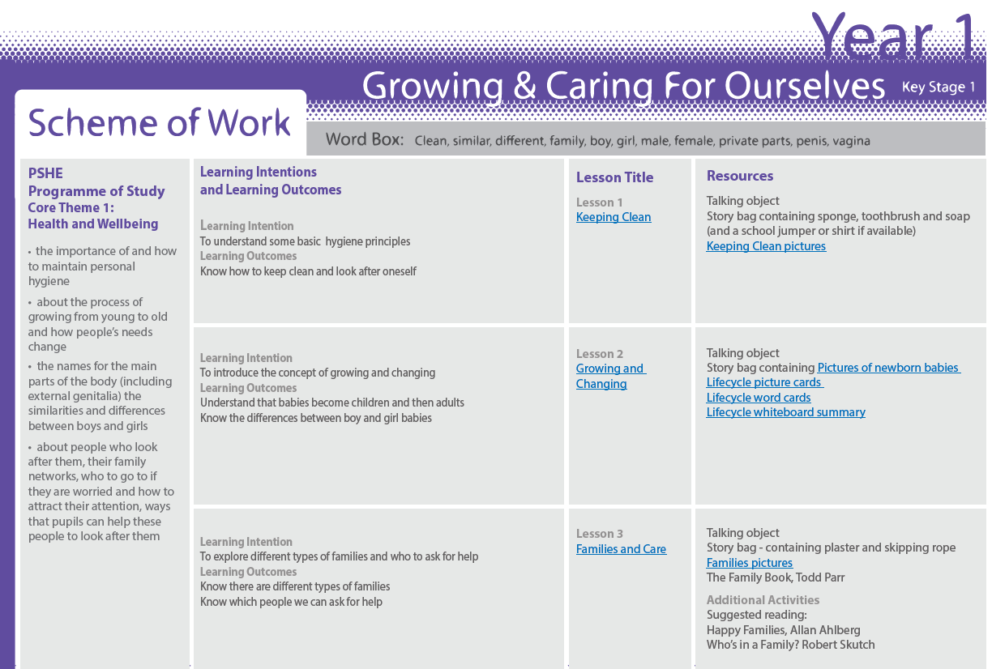
RSE schemes of work:

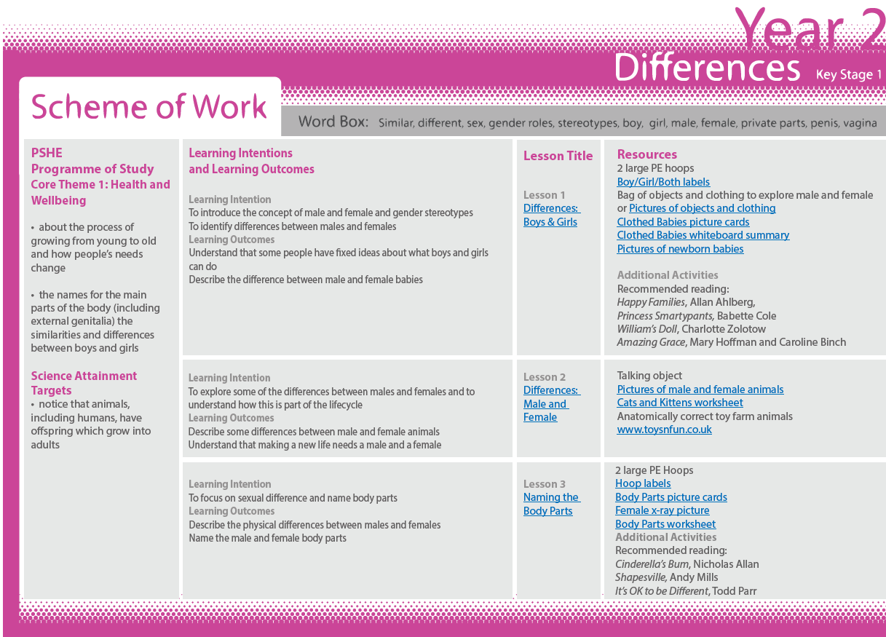

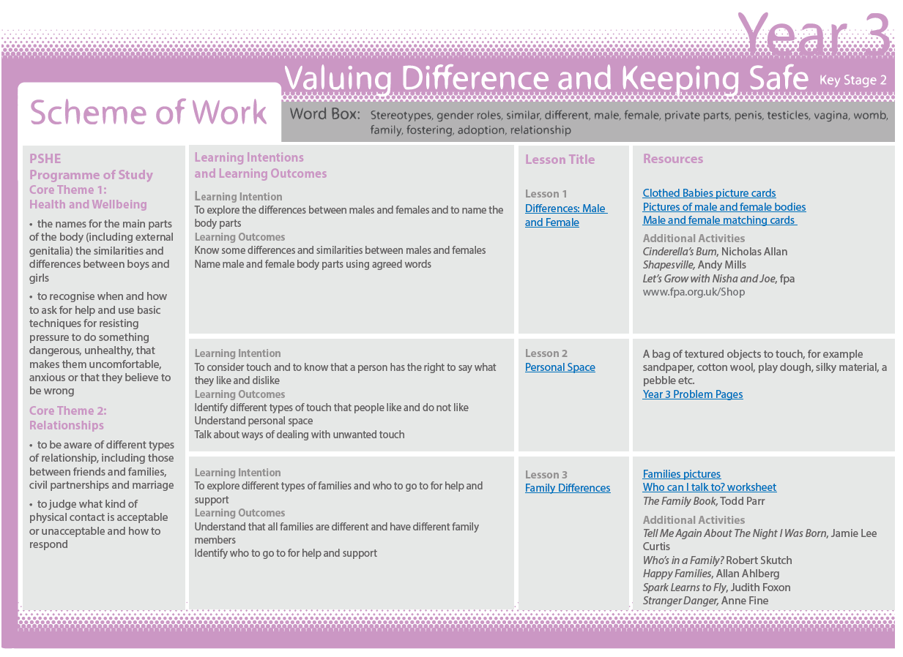

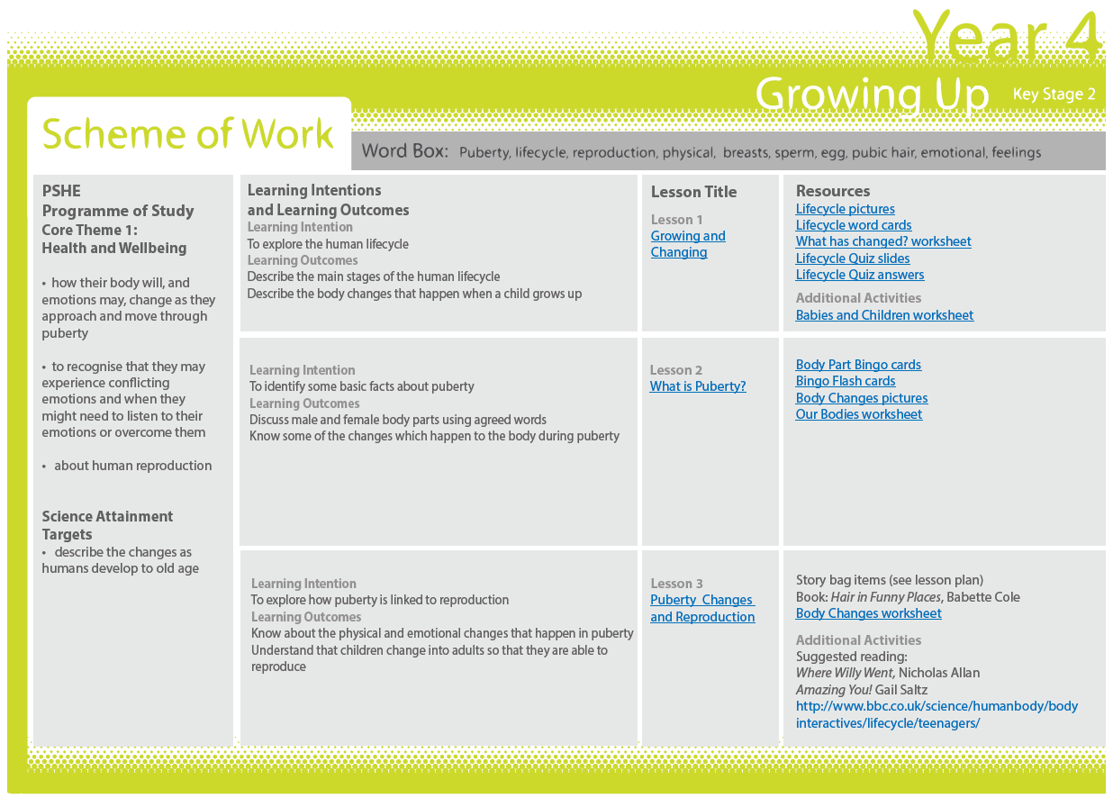

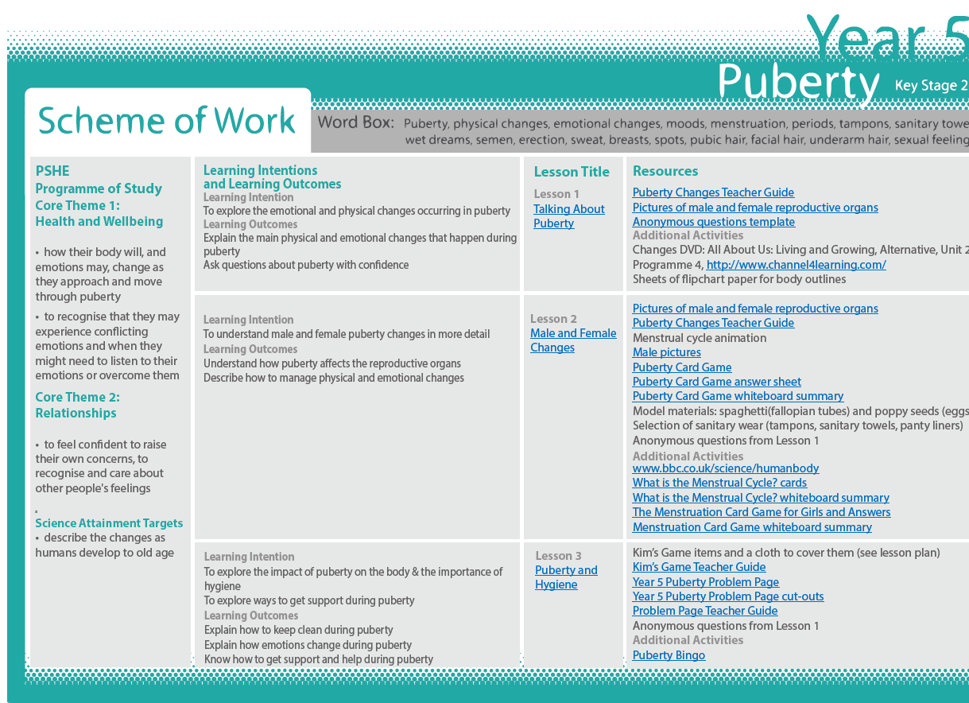

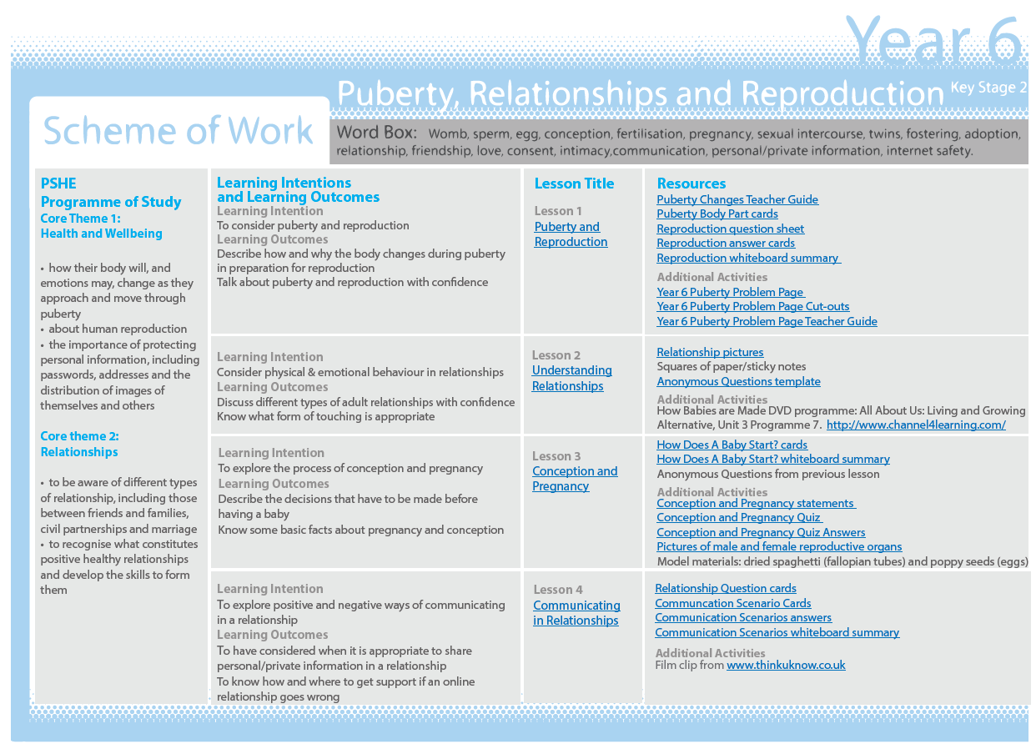

This form should be completed by a parent/carer if, following a discussion with the headteacher, they wish to withdraw their child from the non-statutory sex-education element of RSHE.

Appendix 2: Parent/carer form - withdrawal from sex education within RSHE
To be completed by parents/carers
Name of child |  | Class
Name of parent |  | Date
Reason for withdrawing from sex education within relationships and sex education
Any other information you would like the school to consider
Parent/carer signature

To be completed by the school
Agreed actions from discussion with parents

